performance test
Summary report

Table of contents
1 Introduction 2
1.1 Objective of the report 2
2 Scope of Performance Testing 2
3 Test Approach and Methodology 2
3.1 Approach 2
4 Test Environment and Configuration 3
4.1 Test environment 3
4.2 Performance monitoring 3
5 Test Execution Summary 4
6 Business process diagram 5

Introduction

Objective of the report
The objectives of the performance test activity on Enterprise TurnKey Lender are summarized below –
- Benchmarking the TurnKey Lender Enterprise Enterprise Engine (Decision Engine);
- Identify any performance issues within the identified scope of the engagement;
- Create strong precise requirements to the hardware to be used.

Scope of Performance Testing
The following items are in the scope of work of the performance test:
- The performance test activities are limited to the business transactions as defined in the subsequent sections in this document. The test strategy assumes batch activity during normal business operation;
- Performance testing scenarios that are modeled was carried out on the system to investigate the system response, resource utilization and other infrastructure parameters;
- The response time will be accumulated time taken by all system components: application layer, database, web services and network latencies.

Test Approach and Methodology
The following sections describe in detail the devised strategy to execute the performance test activity of Enterprise Turnkey Lender.
The following performance tests are planned to exercise the system fully and investigate the transaction response of the application.
Each application workflow will be executed with the system in isolation with no other concurrent load.
During this test execution, engine performance would be monitored to gather the critical metrics like CPU Utilization, Memory Utilization, Network/ Bandwidth.

Test Environment and Configuration

Test environment
The following system configuration of the TurnKey Lender Enterprise environment.
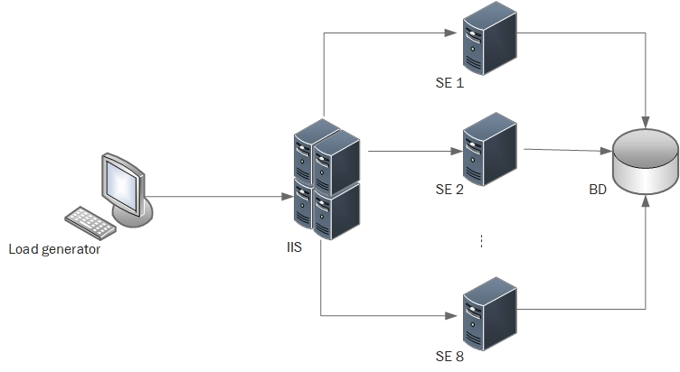
This configuration includes following nodes:
- Load generator;
- Web-server (IIS);
- 1-8 Application servers (TurnKey Lender Enterprise Engine):
- Data Base (MS SQL).

Performance monitoring
During test execution, pre-defined performance metrics will be monitored and analyzed to establish the performance of the application and to detect any performance issues within the application components.
The performance metrics that would be monitored fall under one of the following three broad categories:
- Response and elapsed time
End user response time is depending on the request duration.
- Throughput
Throughput is defined as the number of departures past a given point per unit time.
- Resource utilization (infrastructure)
The following resource utilization metrics will be monitored and measured during all the performance tests:
- Processor Utilization;

Test Execution Summary
The test was conducted to observe the system behavior under the peak load for 300 minutes.
Environment for test has been provided by HP and included 10 VMs in Azure Stack. Each VM – DS3 (Intel® Xeon® CPU E5-2660, 14 GB RAM).
During this time number of nodes for Decision Engines (DE) has been increased from 1 to 8.
Chart below shows a general performance (requests per second) of the system during test depend on number DE.
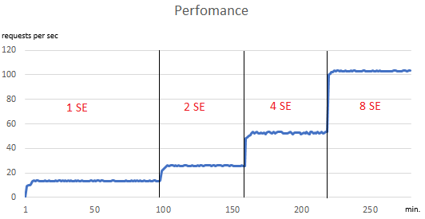
Charts below show how loads (% of CPU usage) for IIS grow up depend of intensity processed requests.
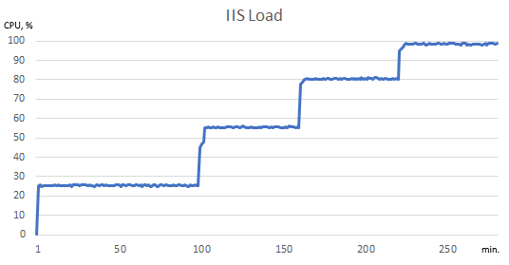
Charts below show how loads (% of CPU usage) for IIS and Data Base grow up depend of intensity processed requests.
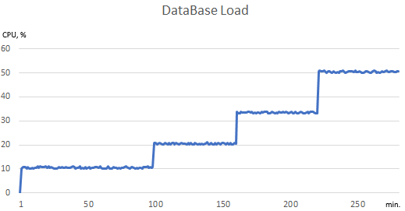

Business process diagram
The business process comprises the following main stages:
- Receiving data from the external system via the integration service;
- Service calculations for preparing data of the scoring model;
- Querying the database to receive necessary information;
- Calculating a score;
- Determining a risk group by using the decision matrix;
- Applying business rules;
- Sending results asynchronously to the external system.
The whole process is executed by 50 nodes used for calculations, 10 nodes to query the database, 1 scoring model nodу, 2 decision matrix nodes.
Global settings
Start
Scoring
Risk class
Final decision
Business rules
Qualitative analysis
Finish

Fig. 6.1. High level diagram of the business process

