Text tags in SignNow are specifically formatted combinations of symbols that can be placed anywhere within your documents in order to preset the location, size and type of various fields such as Signature, Text, Initial fields etc.
1. To use text tags, you must add them to your document before uploading.
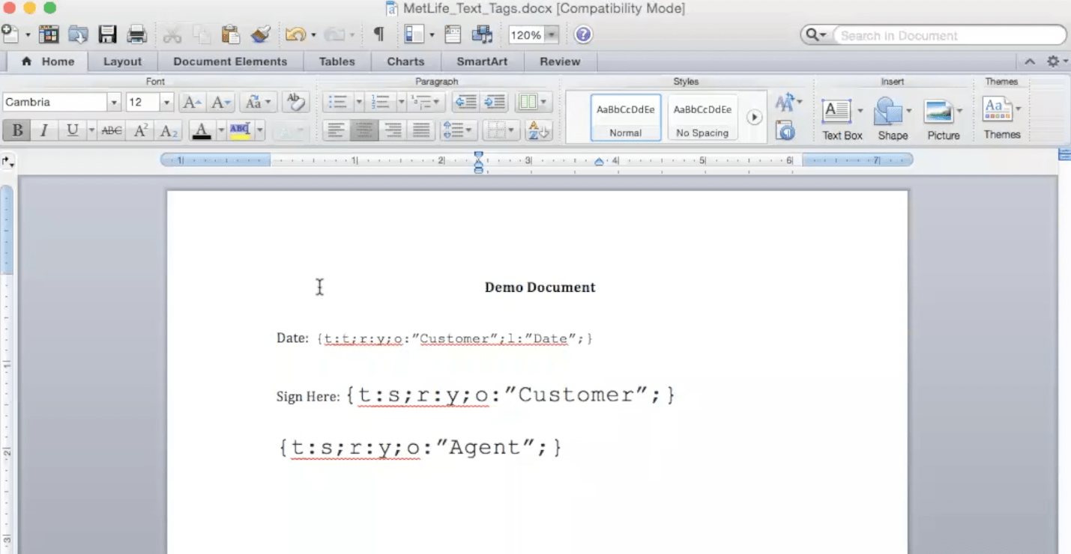
For example, the text tags being used for the ‘Date’ line are the following:
{t (for the Type of field): t (for Text): r (for Required): y (for Yes): o (for Role): “Customer”; l (for Label): “Date”; }
The text tags being used on first the ‘Sign Here’ line are the following:
{ t (for Type of field): s (for Signature); r (for Required): y (for Yes); o (for Role): “Customer”;}
The text tags being used on the second ‘Sign Here’ line are the following:
{ t (for Type of field): s (for Signature); r (for Required): y (for Yes); o (for Role): “Agent”; }
After placing text tags in your document and uploading it to SignNow, the document fields will show up automatically:
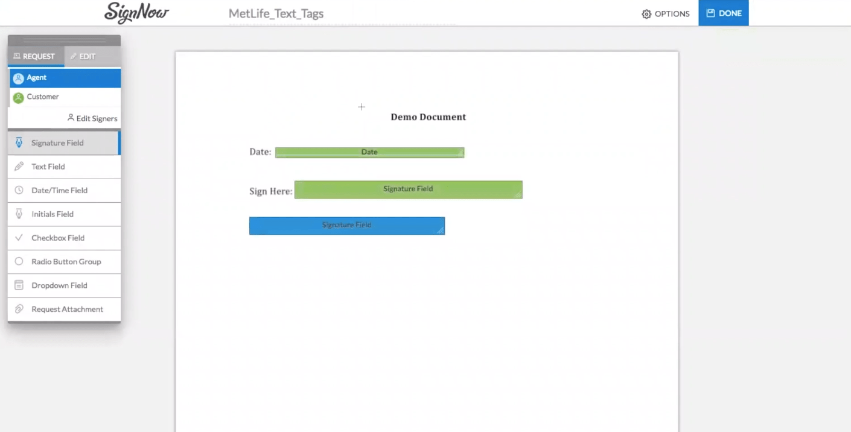
The table below shows the most widely used text tags in SignNow along with the types of fields for which these text tags can be applied.
KEY | What does it mean? | Accepted format & values | When fields need this KEY?
t | TYPE of the field | s (for signature)  i (for initials)  t (for text)  d (for dropdown)  c (for checkboxes) | For every field
r | REQUIRED | y (for required)  n (for optional) | For every field
o | ROLE | " " | For every field
l | LABEL | "" | Only for Text and Drop down fields
dd | DROPDOWN | "option1, option2, option2, ...." | Only for Drop down fields
f | FILE | " ".pdf" | File attachment
w | WIDTH | w (width) | For every field
h | HEIGHT | h (height) | For every field
v | VALIDATOR_ID | v (validator_id) | Only for Text field
You can preset standard fields, such as Initials, and also more complex fields with data validations, such as a US phone number.
1 | To create a field of TYPE signature, with required REQUIREMENT, ROLE 'CEO', WIDTH '100', and HEIGHT '15' | {{t:s;r:y;o:"CEO";w:100;h:15;}}
2 | To create a field of TYPE initials, with optional REQUIREMENT, ROLE 'CEO', and WIDTH '50' | {{t:i;r:n;o:"CEO";w:50;}}
3 | To create a field of TYPE text, with optional REQUIREMENT, ROLE 'CEO', LABEL 'Label', and HEIGHT '75' | {{t:t;r:n;o:"CEO";l:"Label";h:75;}}
4 | To validate a date for TYPE text, with optional REQUIREMENT, ROLE 'CEO', LABEL 'Label', WIDTH '100', and VALIDATOR_ID '13435fa6c2a17f83177fcbb5c4a9376ce85befeb' | Date: {{t:t;r:n;o:"CEO";l:"Label";w:100;v:"13435fa6c2a17f83177fcbb5c4a9376ce85befeb";}}
5 | To validate a US phone number for TYPE text, with optional REQUIREMENT, ROLE 'CEO', LABEL 'Label', WIDTH '100', and VALIDATOR_ID '13cc1d661da456d27b249b73056ed4d1f2e72d8e' | {{t:t;r:n;o:"CEO";l:"Label";w:100;v:"13cc1d661da456d27b249b73056ed4d1f2e72d8e";}}
6 | To validate a US zip code for TYPE text, with optional REQUIREMENT, ROLE 'CEO', LABEL 'Label', WIDTH '100', and VALIDATOR_ID '1671f4eb87444a24e1e00f149bade8b7cf3af5da' | {{t:t;r:n;o:"CEO";l:"Label";w:100;v:"1671f4eb87444a24e1e00f149bade8b7cf3af5da";}}
7 | To validate an age for TYPE text, with optional REQUIREMENT, ROLE 'CEO', LABEL 'Label', WIDTH '100', and VALIDATOR_ID '1a203fa91791b0458608be045a454ba90557fb26' | {{t:t;r:n;o:"CEO";l:"Label";w:100;v:"1a203fa91791b0458608be045a454ba90557fb26";}}
8 | To validate an email address for TYPE text, with optional REQUIREMENT, ROLE 'CEO', LABEL 'Label', WIDTH '100', and VALIDATOR_ID '7cd795fd64ce63b670b52b2e83457d59ac796a39' | {{t:t;r:n;o:"CEO";l:"Label";w:100;v:“7cd795fd64ce63b670b52b2e83457d59ac796a39”;}}
9 | To validate a US state for TYPE text, with optional REQUIREMENT, ROLE 'CEO', LABEL 'Label', WIDTH '100', and VALIDATOR_ID '3123849de563f9e14acacc2739467e3d30e426b6' | {{t:t;r:n;o:"CEO";l:"Label";w:100;v:“3123849de563f9e14acacc2739467e3d30e426b6”;}}
10 | To create a field of TYPE signature, with required REQUIREMENT, and ROLE 'CFO' | {{t:s;r:y;o:"CFO";}}
11 | To create a Field of TYPE Text, with optional REQUIREMENT, with ROLE 'CFO', and with LABEL "notes" | {{t:t;r:n;o:"CFO";l:"notes";}}
12 | To create a Field of TYPE Initial, with optional REQUIREMENT, and ROLE 'CFO' | {{t:i;r:n;o:"CFO";}}
13 | To create a Field of Type Drop down, with required REQUIREMENT, with ROLE 'Employee', with LABEL 'Date', and with DROPDOWNS '2012,2013,2014' | {{t:d;r:y;o:"Employee";l:"Year";dd:"2012,2013,2014";}}
14 | To create a Field of TYPE Text, with a Date label which will auto-fill with current date | {{t:t;r:y;o:"CFO";l:"Date";}}
15 | To create an Invite tag with signing order, with required REQUIREMENT, with ROLE 'Role1', 'Client', 'Manager': | {{t:e;o:"Role1";e:"siri@mailinator.com";order:1;}}  {{t:e;o:"Client";e:"siri2@mailinator.com";order:2;}}  {{t:e;o:"Manager";e:"siri3@mailinator.com";order:3;}}
There can also be more complex tags which consist of a tag_name and the SignNow field creation information as presented in the call PUT /document/.
These complex tags appear in the format {{}} such as {{my signature}} or {{ClientSignatureDate}}.
Here are some of the most popular examples of such complex tags:
Text Tag | {  tag_name:'TextTagExample',  role:'Role1',  label:'Label1',  required:true,  type:'text',  prefilled_text:’family-name',  width:100,  height:20  },
Date Validator Tag | {  "tag_name":"DateValidatorTagExample",  "role":"Role1",  "label":"Date of Birth",  "required":true,  " type":"text",  "height":15,  "width":100,  "validator_id":"13435fa6c2a17f83177fcbb5c4a9376ce85befeb"  },
Initials Tag | {  "tag_name":"InitialsTagExample",  "role":"CLIENT",  "required":true,  "type":"initials",  "height":15,  "width":40  },
Signature Tag | {  "tag_name":"SignatureTagExample",  "role":"CLIENT",  "required":true,  "type":"signature",  "height":15,  "width":200  },
Drop-Down Tag | {  "tag_name":"DropDownTagExample",  "role":"Role1",  "label":"Options",  "required":true,  "type":"enumeration",  "height":15,  "width":100,  "custom_defined_option":false,  "enumeration_options":["All","None"]  },
Attachment Tag | {  tag_name:'AttachmentTagExample',  role:'Role2',  label:'Label2',  required:true,  type:'attachment',  width:100,  height:20  }
Checkbox Tag | {  "tag_name":"CheckboxTagExample",  "role":"CLIENT",  "required":true,  "type":"checkbox",  "height":12,  "width":12,  },
To begin, you can simply copy-paste the needed tag from the table below and add it your document prior to uploading it to SignNow. Height and width are easily adjusted manually, just change the numbers as per your needs.
The vital conceptual advantage of the SignNow e-signature software for enterprise automation is actually a common data area that extends the company but reflects an original business worlflow. You can save time by Importing Data into new document to sign, give an invite link to your partners, suppliers or teammates. Our advanced service simplifies the analytical and audit stages. It lets you run the workflow much more flexibly without involving extra work force. You can indirectly refine the comminucation between partners and allow them to increase customer experience.

How to fill out and sign a add document:
- Create your username and password totally free or log on if you already possess one particular.
- You can sign in with the Single sign-on feature if you possess the PDFfiller profile.|If you possess the PDFfiller account, you can sign in with the Single sign-on feature
- Import the record from your portable or desktop gadget.
- In addition, you can upload the required file from your cloud storage. Our web-based software is compatible with probably the most recommended repositories: Google Drive, OneDrive, DropBox.
- Easily make alterations to your form using our advanced but straightforward PDF Editor.
- Enter the textual content material, place graphics, leave your annotations or comments, etc..
- You may configure fillable elements of diverse kinds: text or date, calculated or dropdown, and much more.
- Organize and put in place the attachment require.
- Put in the Signature Field for sending to sign and gather in-person or multiple e-signatures. If applicable, you can self-sign the form.
- Complete changes using the Done button and proceed to save time by Importing Data into new document to sign.
SignNow is the perfect alternative for automation of company procedures and solution to save time by Importing Data into new document to sign and fast tasks concluding for organizations of all levels workers and complexity. Users can collaborate both externally and internally with providers and consumers. Try out all of the advantages now!

